THERAPEUTIC RIDING SERIES – NORTH SHORE
$240 for first-time program riders. All repeat clients will be charged $350 for the series. No partial or prorated sessions.
Mondays: September 18, 15
October 2, 16, 23, 30
November 6, 13
Time: 12:00-1:00 PM

**Limitations: 185 lb weight limit
Event Status: On Going
Windrush Farm $240 for the series (8 sessions) for first time participants. Repeat clients will be charged $350 for the series. Nor single sessions or partial payments.
479 Lacy Street
North Andover, MA

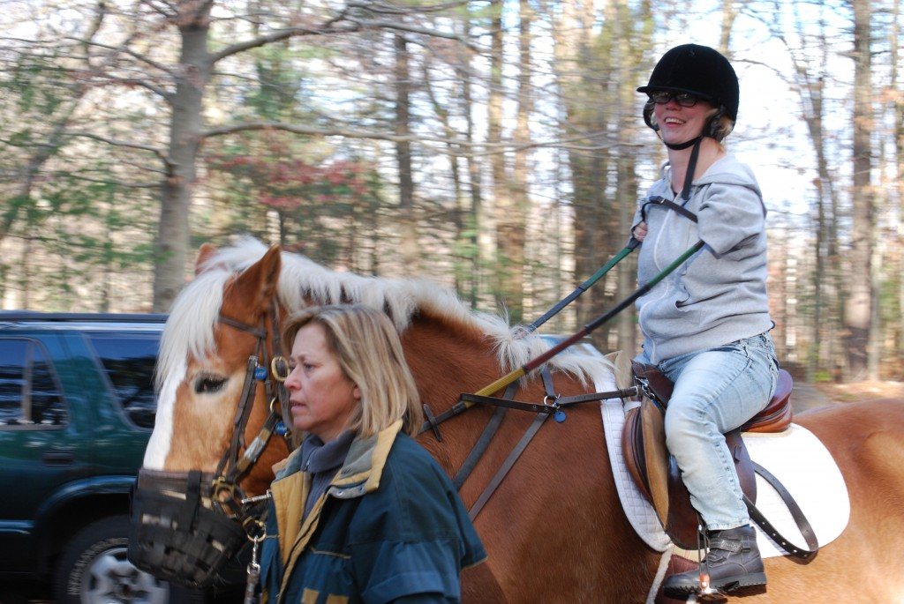
Contact:
Spaulding Adaptive Sports Centers
Contact Name: Sara Carper
Phone: 877-976-7272
scarper@partners.org
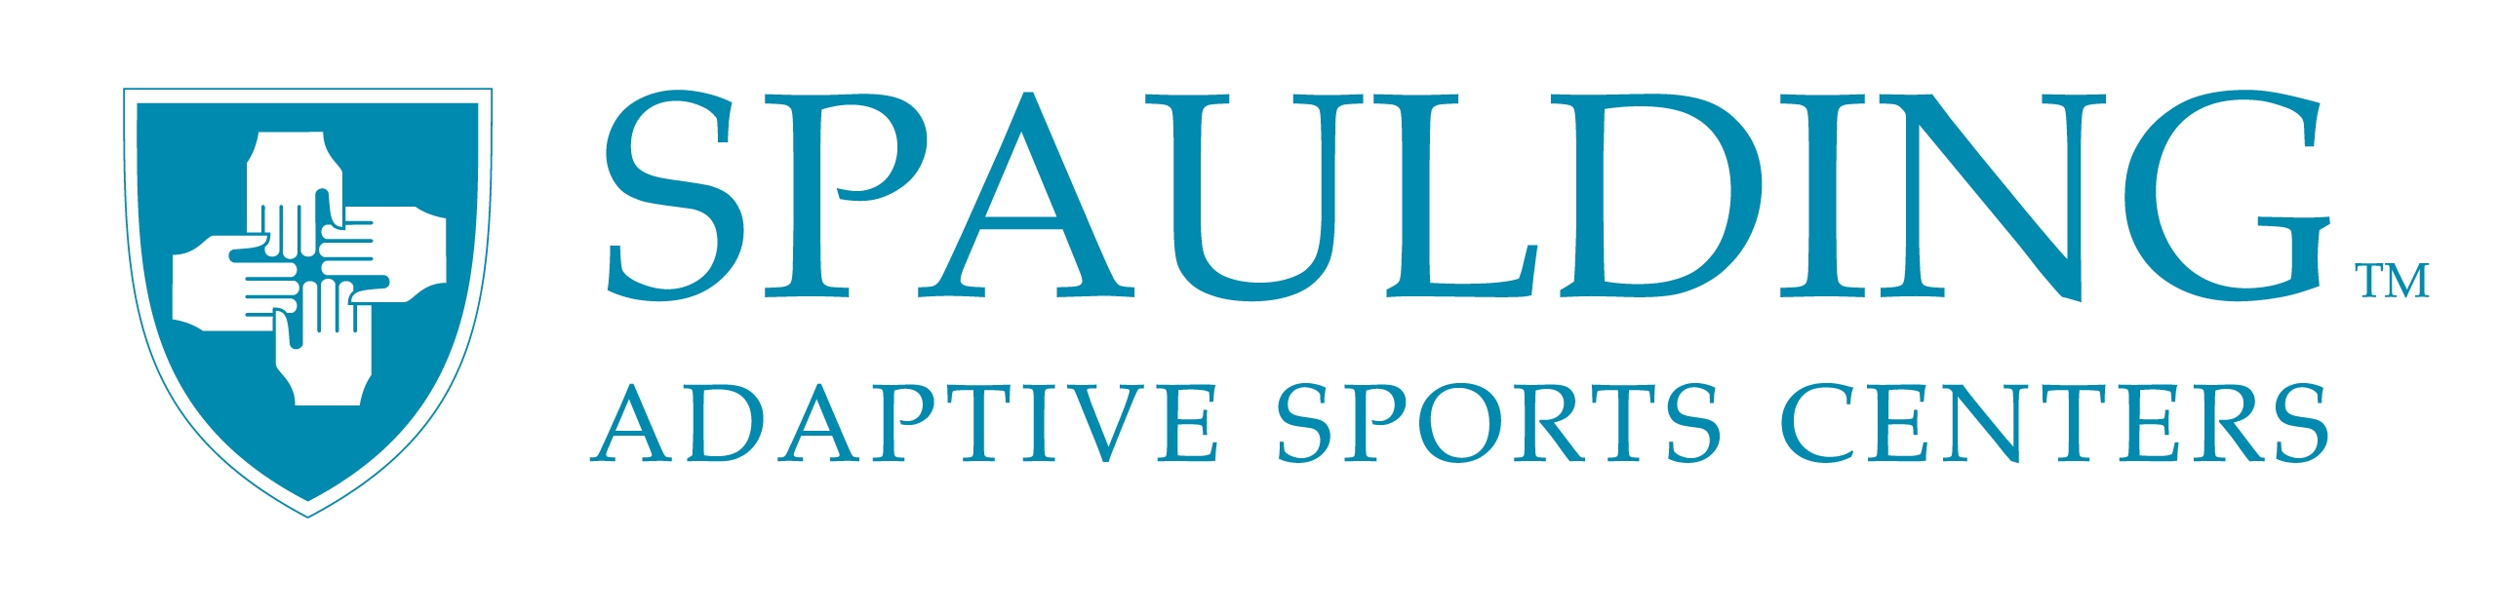
Horseback riding is recognized as one of the more progressive forms of therapeutic recreation and is an ideal activity to supplement traditional therapy. Windrush Farm has carefully chosen and trained horses with adaptive equipment to make riding accessible for those with physical and cognitive disabilities. The ability to control a horse as well as one’s own body inspires self-confidence and creates a special relationship between rider and horse.
Cost: $240 for first-time program riders. All repeat clients will be charged $350 for the series. No partial or prorated sessions.
Limitations: 185 lb weight limit
All skills, ages and abilities welcome.
Therapeutic Riding SERIES II – 2017
Monday, Sept 18, 2017
Monday, Sept 25, 2017
Monday, Oct 2, 2017
Monday, Oct 16, 2017 CLOSED: HOLIDAY
Monday, Oct 23, 2017
Monday, Oct 30, 2017
Monday, Nov 6, 2017
Monday Nov. 13, 2017
To register, please call 877-976-7272

