

We are hiring:
1. Program Coordinator--year-round, part-time position
2. Leaders--seasonal, part-time -- hiking, kayak, winter

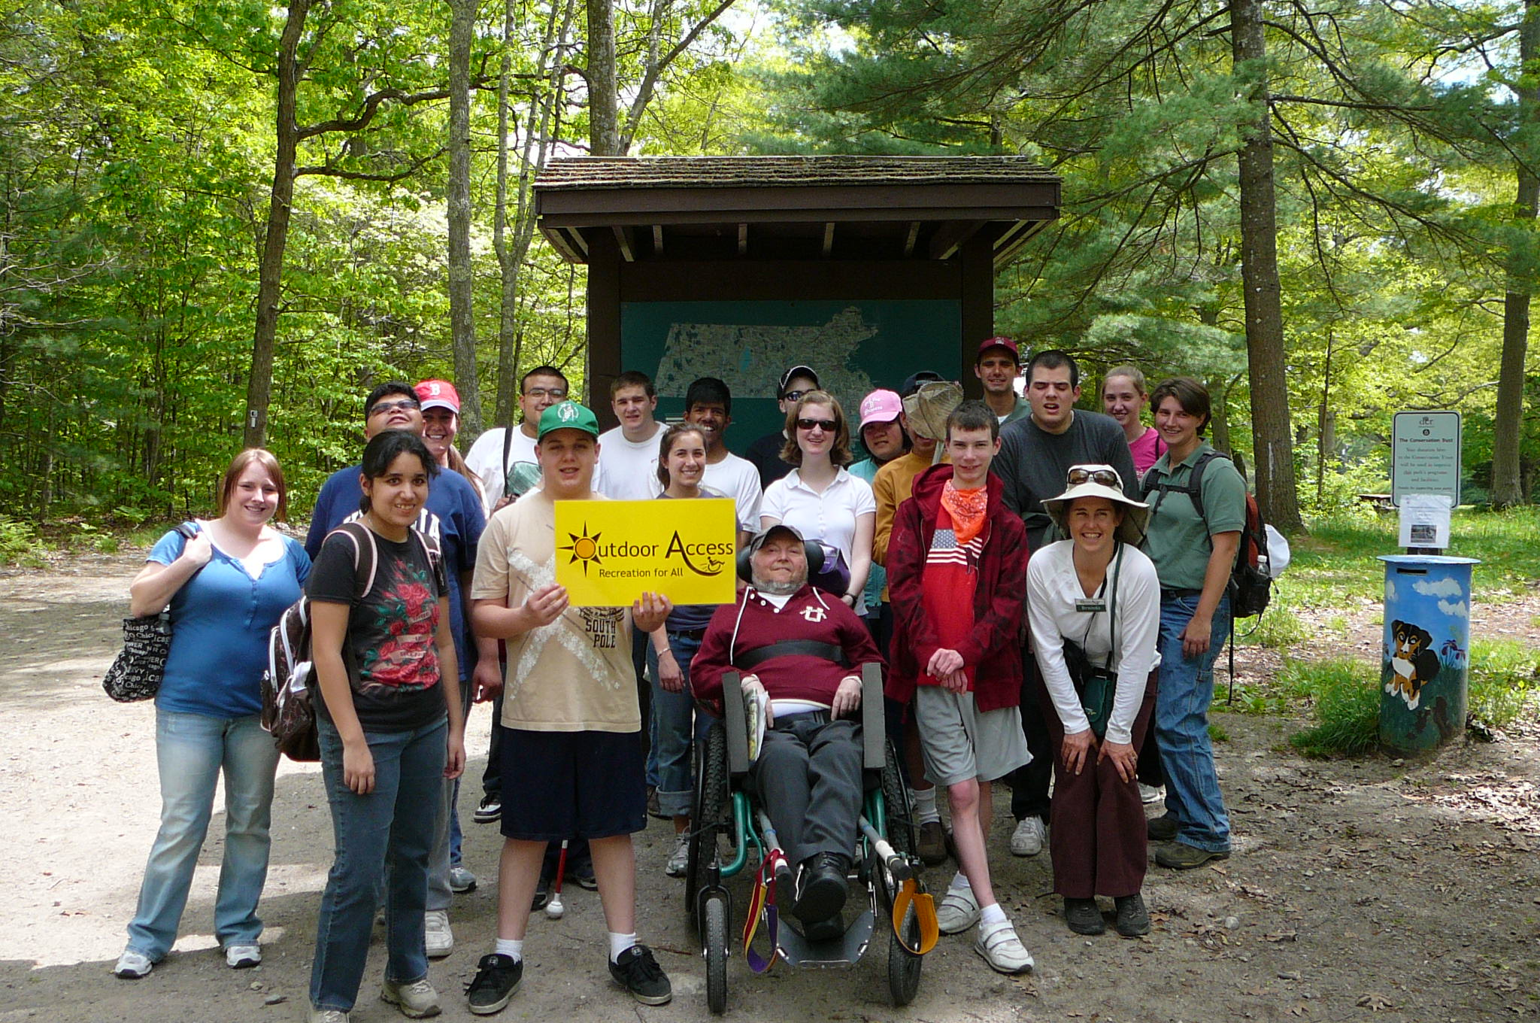
Locations:

Programs throughout MA
Office in Amherst, MA

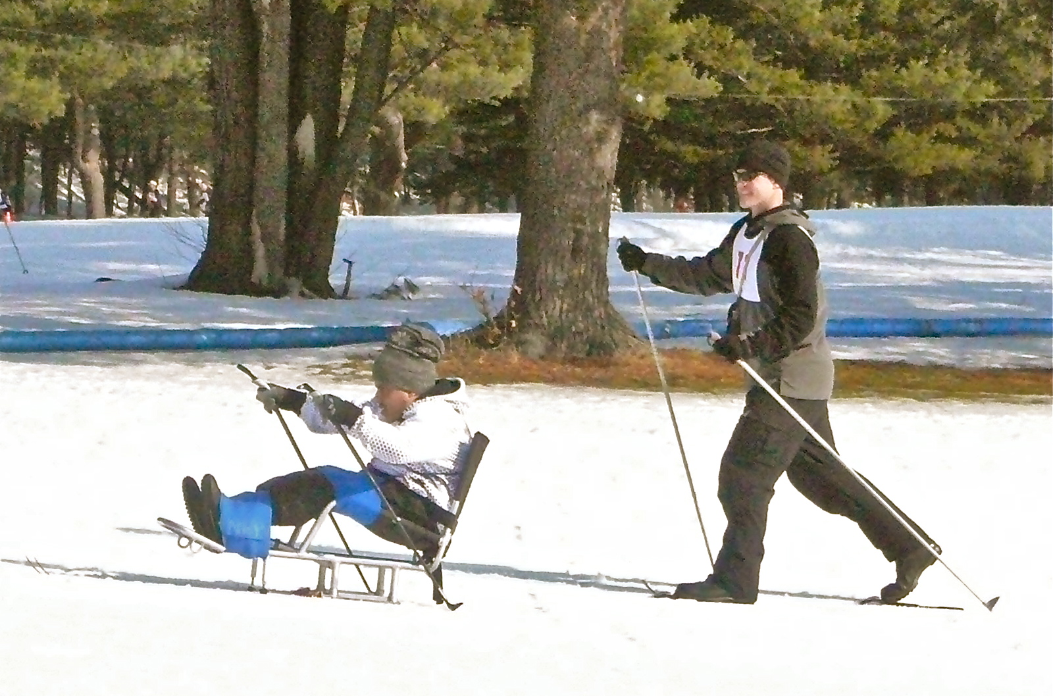
We provide:

Accessible hiking, kayaking,
Winter programs and
special events!

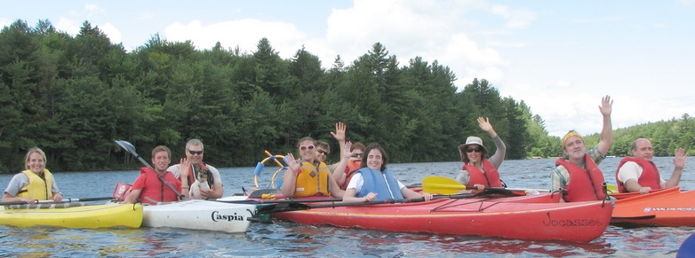

Send inquiries and resume to:

Attn: Brenda K. Davies, Outdoor Access Director
413 259-0009 brenda@outdoor-access.org
Stavros Center for Independent Living

