SESSION 3 WINTER PROGRAMS!
January 6th- March 2nd
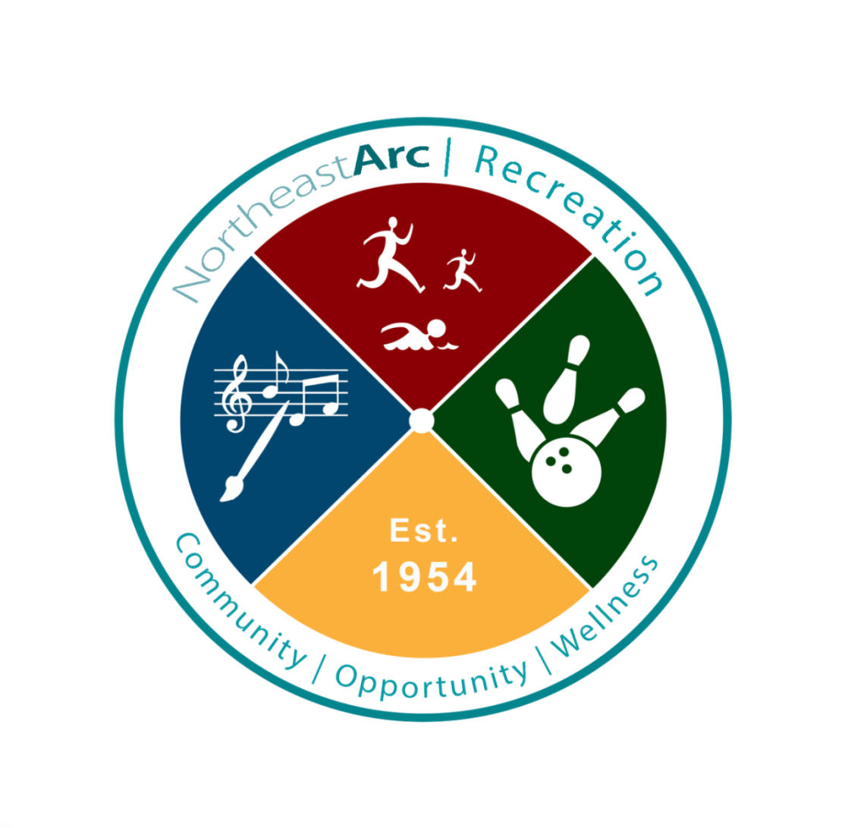

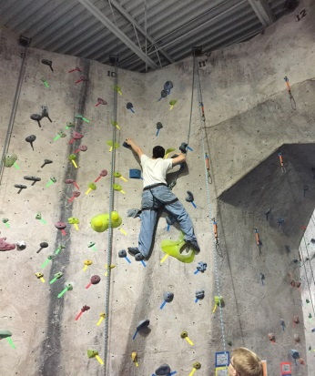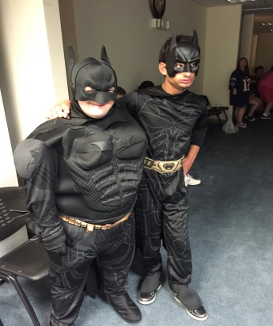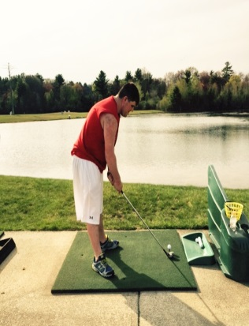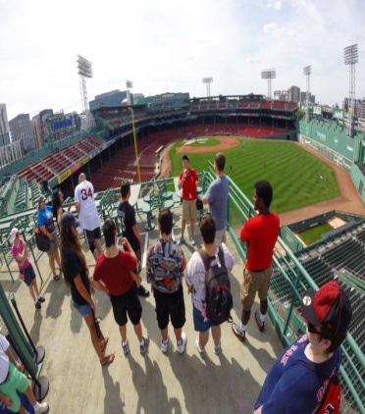

Letter from the Director:
Welcome to the Northeast Arc Recreation department! We are very excited that you are interested in participating in our recreation programs! Here at the Northeast Arc, we strive to provide families with ample opportunity to be involved with year-round recreational programs, social activities, sports and fitness, arts, aerobic exercise, leisure, music, and “healthy living” classes adventure outings and special events. It is our priority to meet the needs of each family we serve. We hope that you find the Northeast Arc Recreation Department a haven for success, personal growth, socialization, friendship and FUN!
In an effort to maintain constant communication with our families and maximize program quality, we hold bi-annual “family meet and greets!” All families are invited to come and meet the staff, other families, and most importantly, openly discuss how we can improve and better our recreational programs! (Dates for these meetings will be communicated to our families through email and flyers).

Thank you for your interest in the Northeast Arc Recreation Department!

Sincerely,
Adam Quinn (Director of Recreation and Leisure)

Contact Us
Adam Quinn (Program Director) …………………………………………. (978)-624-2308
AQuinn@ne-arc.org
Katie Sweet (Assistant Program Director)………………………………… (978)-624-2385
KSweet@ne-arc.org
Recreation Department General Contact…………………………………... (978)-766-4368
Recreation@ne-arc.org

SESSION 3 WEEKLY RECREATION PROGRAMS
January 6th- March 2nd

To register for programs, call 978-624-2308 or email: Recreation@ne-arc.org

Monday: North Shore Bowling League
Ages: 13+ years Fee: $10 a week Staff Ratio - 8:1 Time: 6:00 PM—7:30 PM
Location: Sunnyside Lanes, Danvers MA
Come and have a blast as you bowl alongside your friends. Each player bowls for 2 games as we learn turn taking skills, social skills and good sportsmanship.

Tuesday: Zumba Dance Exercise Class!
Ages: 14+ Fee: $65 Staff Ratio – 8:1 Time: 6:00 PM – 7:00 PM
Location: Northeast Arc Center for Excellence, Danvers MA
Join us as we take the "work" out of workout, by mixing low-intensity and high-intensity ADAPTIVE moves for an interval-style, calorie-burning dance fitness party. Once the Latin and World rhythms take over, you'll see why Zumba Fitness classes are often called exercise in disguise. Super effective and really fun! NO CLASS ON 1/24

Tuesday: ***NEW - PAINT NIGHT!***
Ages: 10+ Fee: $80 Staff Ratio – 4:1 Time: 5:00 PM – 6:00 PM
This NEW program uses the unique process of creating art in a relaxed and enjoyable environment for participants to explore themselves creatively using various mediums. This program includes individualized creative activities, and group activities to promote imagination and inspiration, while also working to develop stress relief techniques, self-confidence, and communication skills. Participants are encouraged to only bring their sense of creativity, adventure, and originality with them!

Tuesday: Open Dances — January 24th & February 28th
Ages: 13 + years Fee: $5 Staff ratio – 8:1 Time: 6:30 PM—8:30 PM
Location: The Northeast Arc - 6 Southside Rd. Danvers MA
This dance is NOW open to everyone 13 years and older. Bring your dancing shoes and prepare for a night of fun! Drinks and snacks are provided. This event takes place the fourth Tuesday of every Month

Wednesday: Recreational Swim
Ages: All Ages Fee: $65 Staff Ratio – 4:1 Time: 4:00 PM—5:00 PM
Location: Hogan Regional Center, Danvers MA
Swimming is a great way to spend time with friends, while getting exercise! Join us for a fun filled hour of splashing around, swimming laps and pool games! Doctor’s signature required to participate

Wednesday: Cape Ann bowling League
Ages: 22+ years Fee: $10 a week Staff Ratio – 8:1 Time: 6:30 PM—8:00 PM
Location: Cape Ann Lanes, Gloucester MA
Our Cape Ann bowling league is for all of our participants closer to Cape Ann than Danvers. This league is open to all ages and is fun for everyone. We bowl alongside our friends for 3 games while we learn turn taking, social skills and good sportsmanship.
Thursday: Heritage Bowling League
Ages: 22+ years Fee: $10/ week Staff Ratio – 8:1 Time: 3:00 PM—4:30 PM
Location: Metro Bowl, Peabody MA
This league is open to our 22+ crowd and is fun for everyone. Come bowl for 3 games while we learn turn taking, social skills and good sportsmanship.
Thursday: “Seasoned Chef’s” Cooking for ADULTS!
Ages: 22+ years Fee: $120 Staff Ratio – 4:1 Time: 5:00 PM—6:30 PM
Location: Northeast Arc Center for Excellence, Danvers MA
This class offers fun, healthy, and delicious recipes that are easy to make at home! Not only is this class a great way to learn how to cook, but it is a great way to build relationships. When registering please inform us of any food allergies.

Thursday: Arts and Crafts
Ages: 13+ years Fee: $80 Staff Ratio – 4:1 Time: 7:00 PM—8:00 PM
Location: Northeast Arc Center for Excellence, Danvers MA
This class offers different imaginative projects each week that for the most part are finished to be taken home that same night. You will be able to make items to keep for yourself or even give as gift

Friday: Young Apprentices – Cooking for TEENS!
Ages: 13-21 Fee: $120 Staff Ratio – 4:1 Time: 5:00 PM—6:30 PM
Location: Northeast Arc Center for Excellence, Danvers MA
Time: 5:00 PM—6:30 PM
This class offers fun, healthy, and delicious recipes that are easy to make at home! Not only is this class a great way to learn how to cook, but it is a great way to build relationships. When registering please inform us of any food allergies!

Friday Night Happenings
Ages: 13+ Fee: $15/Week Staff Ratio – 8:1 Time: 6:30 PM—8:30 PM
Location: Northeast Arc Center for Excellence, Danvers MA
Please see Friday Night Happing segment for more details

Saturday Outings
Ages: 13 + Fee: $30 + Ticket Price Staff Ratio – 4:1
Please See Saturday Outings page for more information.

Specialty Programs (Select Dates Only)
Music Therapy
Ages: 2.5 + Fee: $120 Staff Ratio – 4:1 Time: Call for details
Location: Northeast Arc Center for Excellence, Danvers MA
2017 Dates:
- March 4th- April 8th 2017
- June 21st- July 29th 2017
- October 14th- November 18th 2017
9:00 – 9:45am - Music Makers
For children ages 2.5-6 this is a development-oriented
program where children can explore, play and grow as they learn socialization skills using songs, instruments and movement to encourage musical, social, physical, and
emotional growth and learning. Parent participation is required for this session.
10:00 – 10:45am -Sing and Play Together
For children ages 7-12 come sing along with new friends in this music therapy group that focuses on language and communication skills. Designed for children with emerging and developing verbal skills to participate in a supportive and therapeutic group activity, group members will be encouraged to communicate and participate using multi-sensory systems that work best for them.
Parent participation is required for this session.
11:00 – 11:45am - Music, Friends & Me!
For children ages 13+. We will listen to our favorite tunes, record new songs, and have a great time rocking out! Participants will be able to make new friends and develop their love for music.

Creative Movement
Ages: 2.5 - 17 years Fee: $90 Staff Ratio – 4:1 Time: Varies for age groups
Location: Northeast Arc Center for Excellence, Danvers MA
2016 Dates:
- January 7th – February 11, 2017
The Creative Movement group is an integrated group that allows children of all abilities to express themselves through movement in a relaxed and creative atmosphere. A love for music and movement is all that is needed. Bring your energy and creativity!
9:00 to 9:45 (Ages 2 to 6 years)
10:00 to 10:45 (Age 7 to 11 years)
11:00 to 11:45 (Ages 12 to 17 years)

SESSION 3 FRIDAY NIGHT HAPPENINGS
January 6th- February 24th
6:30-8:30 PM
** Medical Fact sheet and intake interview required**
$15 a Week
January 6th- Zumba
Tonight, we are going to dance and work out at the same time! Wear your workout clothes and some sneakers. We will also be enjoying some healthy snacks!

January 13th- Carnival Night
One of our favorite nights! Carnival games, prizes, and ice cream! Could not ask for anything more!

January 20th- Ugly Sweater Dance
For the first dance of the session, we are dressing up in our best Ugly Sweater. Dress to impress, dance and have a great night!

January 27th- Pizza and Game Night
Tonight, we will be enjoying everyone’s favorite food, pizza! We will also be playing board games and socializing! (Please bring an additional $3 if you want pizza).

February 3rd- Paint Night
We are mixing things up tonight and inspiring creativity! Come paint and relax with us! Everyone brings home a painting that they painted themselves! (Please bring an additional $2 for cost of canvas).

February 10th- NO FRIDAY NIGHT HAPPENINGS TONIGHT because we want everyone to attend the prom!
The Night to Shine Prom is located at the North Shore Community Baptist Church, 9 Hart Street, Beverly, MA 01915. It is FREE but you MUST REGISTER @ http://nscbc.org/nighttoshine/ . See you there!

February 17th- Valentine’s Dance
In the spirit of Valentine’s Day, we will be hosting a lover’s dance! Bring the one you love or come mingle, just make sure you bring your dancing shoes!

February 24th- Bingo Night at Endicott College
Tonight, we are going to enjoy another night of Bingo with all of our friends at Endicott College! Get ready to win some prizes! Address: 376 Hale St, Beverly, MA 01915
SESSION 3 SATURDAY OUTINGS
January 7th- February 25th
Ages 13+
** PRE-REGISTRATION of $30 required, additional fees for ticket prices apply **
To register please contact ADAM QUINN at AQuinn@ne-arc.org or 978-624-2308 and fill out appropriate registration form
Drop-off and pick-up are at 6 Southside Road
(Ratio: We keep our programs at a 1:4 staff ratio. Our staffing will determine the number of individuals allowed to attend each outing.)
LUNCH OPTIONS: Pack a lunch or bring money to purchase one
In case of inclement weather during outdoor outings, we’ll have an alternative activity planned.

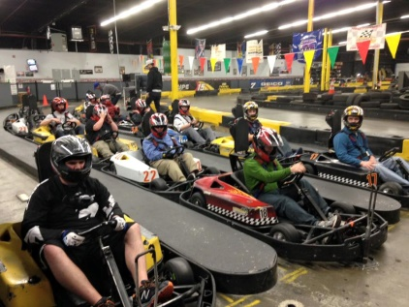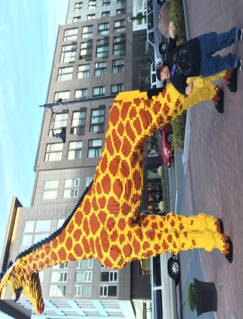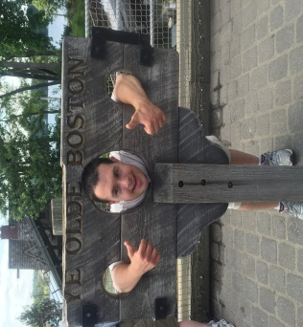

January 7th Chunky’s Movie Theater 10:00 – 3:30
Today, we head to the Chunky’s to enjoy the movie Sing in a spacious, comfortable, and UNIQUE theater. Pizza and ice cream are included in the ticket price!
Lunch: Pizza and Ice cream included Tickets: $19

January 14th Danvers Indoor 1:00 – 4:00
Today, we visit Danvers Indoor. This is an opportunity for our athletes to participate in a safe, fun and challenging sports environment. We are renting out a field and playing every sport you can think of!
Lunch: Pack a lunch! Ticket: $15

January 21st 20,000 Leagues 12:00 – 4:30
Imagine, an accidental discovery leads you to an incredible underwater adventure aboard a mysterious submarine! Will you be able to solve the secrets that lie beneath the sea or will the challenges prove to be beyond your depth? I know we can all do it together!
Lunch: Pack a lunch! Tickets: $17

January 28th Disney on Ice 1:00 – 5:30
Today, we are heading to Disney on Ice Passport to Adventure. We will enjoy upbeat music, lovable characters, and unforgettable moments with all of the Disney characters!
Lunch: Pack a lunch! Ticket: $28

February 4th Clay Dreaming 12:00 – 4:00
It is easy and fun for people of all ages to paint their own pottery at Clay Dreaming! This outing is creative and fun for everyone!
Lunch: Papa Gino’s Tickets: $20

February 11th Seussical the Musical 10:30 – 3:30
Today, we head to the Open Door Theater in Acton, MA to enjoy a unique live theater performance of Seussical which has been specially adapted to serve the needs of audience members on the autism spectrum or with sensory sensitivities. It all begins with a strange and fantastic red-and-white-striped top hat!
Lunch: Pack a lunch! (Light snack and drinks included) Tickets: $10

February 18th Town Line Bowling 12:00 – 3:30
Today, we will be heading over to Town Line Luxury Lanes for a fun day of bowling! Town Line offers a newly renovated bowling center, vibrant lighting, a superior sound system, and above all, bowling!
Lunch: Pack a lunch! Tickets: $15

February 25th Lynnfield Marketplace 12:00 – 4:00
Today, we head to Lynnfield Marketplace for a fun day of shopping and ice skating if you would like! Make sure you bundle up because we will be outside!
Lunch: Panera Bread (If skating) Tickets: $10

Registration Information
The Northeast Arc Recreation Department runs on a fiscal year calendar starting July 1st and ending June 30th. We run our programs in 6 different sessions throughout the fiscal year, and are all open enrollment. Each session offers new and exciting programs! Each session runs for 8 weeks at a time. Our 2016/2017 schedule is below:
Session 2: October 31st – December 24th
Session 3: January 6th – March 2nd
Session 4: March 3rd – April 27th
Session 5: April 28th -June 22nd

New Participants: In order to ensure that our programs meet your needs, all new participants are required to schedule an introductory meeting with the Recreation staff, and may include parents, legal guardians etc. For information on scheduling your meeting please contact either Adam Quinn or Daniel Perednia.
Weekly Programs: To register for a weekly program, please contact the Recreation Department at (978)-624-2308 or email Recreation@ne-arc.org
Saturday Outings: To register for a Saturday outing, Please call or email Adam Quinn at
978-624-2308 or AQuinn@ne-arc.org
Payment Procedure: Payments are due in full before the program begins. Upon receiving program registration confirmation, please pay for the program by cash, check or credit card. Please call Adam Quinn or Daniel Perednia to pay by card. Checks can be made out to “Northeast Arc” and sent to:
Adam Quinn
6 Southside Rd.
Danvers MA 01923

*PLEASE NOTE: REGISTRATION WILL NOT BE COMPLETE UNTIL PAYMENT IS PROCESSED.

Program Social Stories

We provide a social story for each program that is offered through our recreation department. These can be found on the Northeast Arc’s website under each recreation program.

Our Social Stories are a written and visual guide describing various social interactions, situations, behaviours, skills or concepts that our individuals may be faced with.

A Social Story describes a situation, skill, or concept in terms of relevant social cues, perspectives, and common responses. The goal of our Social Stories is to share accurate social information with our individuals in a reassuring manner that is easily understood.

Policies and Procedures

Pick Up and Drop Off
To help us provide safe, quality programs, participants are to be escorted into programs sites. Do not leave anyone at any of our program sites without making sure the program staff has arrived.

BEFORE their escort can leave the building, please make sure participants are checked in with a "Recreation Staff Person". There are several programs running in the building on a daily basis, and as a result, there may be staff in the building, but they are not available to cover recreation participants.
Please note the START and FINISH times of each program and plan accordingly. Participants should not arrive more than 15 minutes early or be picked up later than 15 minutes.

Emergency Protocol
The Northeast Arc Recreation staff will not utilize restraints in any situation.
In the event of an emergency or severe behavioral occurrence, the supervising employee will call 911, safely secure the area, and notify the parent/guardian immediately.
In the event of minor injuries, (bumps, bruises, scrapes) first aid care will be provided on site.

Follow us on Social Media for pictures, program updates and success stories!

@Nearc_Recreation Northeast Arc Recreation @NearcRec

