2 DAY EXTENDED CYCLING RIDE- MARTHA’S VINEYARD
Saturday October 14 - Sunday October 15
Event Status: Planned
Martha's Vineyard $100 including ferry and lodging at Camp Jaberwocky
Martha's Vineyard, MA

Disability Served: Autism, Brain Injury, Hearing, Intellectual, Mental Health, Physical, Visual
Communities Served: Adult, Family, Teen, Veterans, Youth
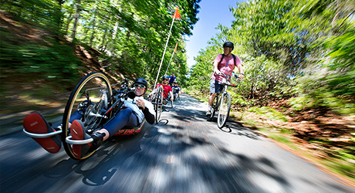
Contact:
Spaulding Adaptive Sports Centers
Phone: 877-976-7272

Spaulding’s Extended Cycle Ride is open to riders who are eager for 2 days of cycling. Spaulding Adaptive Sports has a fleet of handcycles and recumbent 3-wheeled bikes for participants’ use. The program is delivered under the supervision of Spaulding clinicians and adaptive sports professionals. Staff members help each participant find an appropriate cycle based on that person’s strengths. The bike ride travels along the scenic Martha’s Vineyard.
Pre-registration is required.

Saturday, October 14, 2017 through Sunday, October 15, 2017

