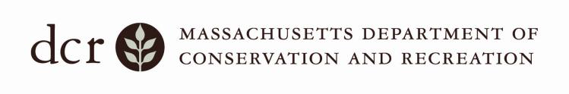
Universal Access Program

Accessible Outing at

Castle Island
2010 William J. Day Boulevard, South Boston, MA

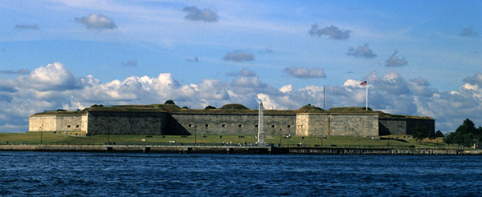

Come explore the Boston shoreline with Outdoor Access! During this urban outing, enjoy scenic views of Boston Harbor and the Boston Harbor Islands and learn about the history of Fort Independence. Assistive equipment such as Terra Trek mountain wheelchairs and all-terrain walkers will be available to try. Bring a lunch or grab a hot dog from Sullivan’s and collect the Castle Island passport stamp! Sighted guides available.
$3 per person, $10 for families, $25 for groups

Funded through Spaulding Rehab Hospital to provide opportunities for working people with disabilities to enjoy parks.

Pre-registration required. Call 413-259-0009
Saturday, October 31st
^{Costumes Welcome!}

For further information on accessible recreation opportunities in MassParks,
call DCR’s Universal Access Program at 413-545-5353 or go to http://www.mass.gov/dcr/universal-access

